# If I have a concern about a child, I should follow the procedure outlined below:

I have concerns about my/a child’s safety

If I am still concerned, I can talk to a member of the Safeguarding Team. (Mr Mc Closkey/Mrs Kilcullen)

If I am still concerned, I can talk/write to the Chairperson of the Board of Governors

(Lousie Stewart ) or contact the designated Governor (Mrs Mairead Phair)

I can talk to the class teacher

## It should be noted that information given to a member of staff about possible child abuse cannot be held in confidence. In the interest of the child, staff will need to share this with other professions. However, only those who need to know will be told.



St.Mary’s Primary School Fivemiletown

Child Protection & Safeguarding

A GUIDE FOR PARENTS/GUARDIANS



Full copies of our Child Protection Policy are available on request by contacting

the school office on 02889521315 or emailing the Principal on

bmccloskey287@c2ken.net

The Principal and Staff of St.Mary’s PS will update the school’s Child Protection Policy in light of further guidance and legislation as necessary and review annually.

REMEMBER

If you are concerned about the welfare of your/ any child? Have you reason to suspect a form of abuse may be involved? Have you been informed about a case of suspected abuse?

THEN DO NOT DELAY!

Report your concern immediately to a member of our Safeguarding Team. The action taken at St.Mary’s PS is that of informing Social Services and seeking advice form the Child Pro tection Te am at the Education Authority - South Eastern Region, and following Child Protection Policy and Procedures.

## The school will NOT be involved in investigating the suspected abuse.

St.Mary’s P.S receives support and advice regarding all child protection and safeguarding issues from:

At any time, I can talk to the Duty Social Worker at the Gateway Team on

028 374 15285

or by contacting the PSNI on 101 and ask for Public Protection Unit

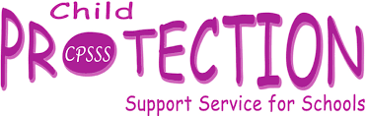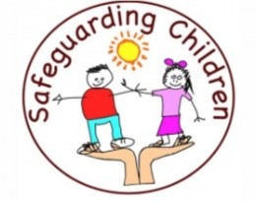

**02895985590**

**CHILD PROTECTION POLICY**

Policy Statement

It is our policy at St.Mary’s PS to safeguard the welfare of all the children in our care by endeavouring to protect them from all types of abuse. Principles

The following principles underpin our Child Protection Policy:

* Children are listened to and taken seriously. - In any incident, the child’s welfare must always be paramount; this overrides all other considerations.
* A proper balance must be struck bet ween protecting children and respecting the rights and needs of parents and families but where there is conflict, the child’s interest must always come first.

There are 4 main kinds of abuse - the following are details and possible symptoms:

Neglect Abuse: The confirmed or suspected, persistent or significant neglect of a child. Symptoms may include hunger, inadequate clothing, constant lack of cleanliness and regular tiredness or failure to thrive.

## Physical Abuse: Confirmed or suspected deliberate injury to a child or wilful or neglected failure to prevent physical suffering to a child. Symptoms may include unexplained injuries, bruises or burns, especially repeated ones. There may be a refusal to explain these and/or fear of physical contact.

Emotional Abuse: Emotional ill treatment or rejection. Symptoms may include delays in physical, mental and emotional development and unexplained fears.

## Sexual Abuse: Sexual abuse involves forcing or enticing a child to take part in sexual activities. The activity may involve physical contact. It may also include non-contact activities such as involving children looking at or in the production of pornographic material or watching sexual activities or encouraging children to behave in sexually inappropriate ways.

It is always possible the above symptoms could be attributed to other family situations and certain other causes. However, the fact that they may be

attributed to child abuse must not be ignored.

Implementation of Procedure

Members of the Safeguarding Team shall be the people with special responsibility for dealing with cases of suspected Child Abuse.

At St.Mary’s PS these members are Mr Mc Closkey (Principal) and Mrs Kilcullen

The role of the Safeguarding Team is to:

* Listen to the child
* To refer the case to Duty Social Worker and/or PSNI and to seek advice from Social Services and the Child Protection Support Services for Schools.
* To support the child.

Where non-teaching staff are alerted to the possibility of abuse, they will inform a member of the Safeguarding team immediately.

# St.Mary’s P.S is a Safeguarding school. This model shows how child

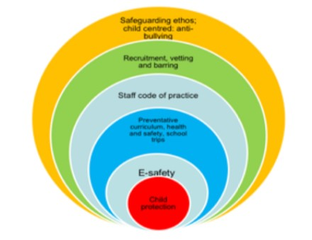protection is at the heart of our ethos.

Conduct of Staff

The conduct of staff towards children must be above reproach at all times. In safeguarding the welfare of the children, staff must never abuse their position of trust. The school has a staff code of conduct and all members of the teaching and non- teaching staff adhere to this policy.

Training

Both the teaching and ancillary staff have been trained by a member of the Safeguarding Team and this training will be updated regularly. The subject will also be addressed in the induction of newly appointed staff, both teaching and non- teaching.

Allegations Against Staff

Any complaints made that a member of staff has abused a pupil will be thoroughly investigated using the appropriate Child ProtectionProcedures. Advice will immediately besought from CCMS, CPSSS and Social Services. Preliminary enquiries will be carried out. These enquiries will have regard to the welfare of the child concerned and of the other children in the school, to the efficient functioning of the school and to the rights of the individual against whom the complaint has been made.

Procedure where a complaint is about a member of staff

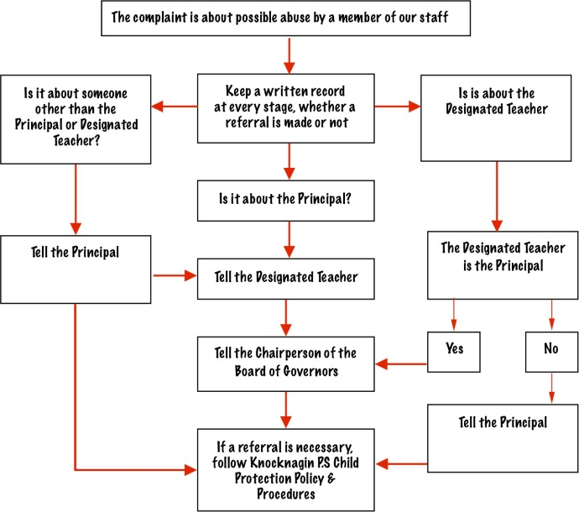

If a referral is necessary follow St.Oliver Plunkett’s Child Protection & Policy Procedures